Minuteman III Silo Graphics
from Nuclear Heartland: A guide to the missile silos of the United States

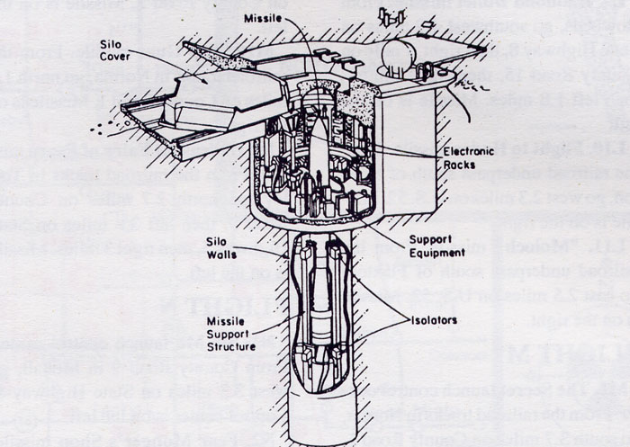

Underground view of a Minuteman missile silo from Boeing Corporation
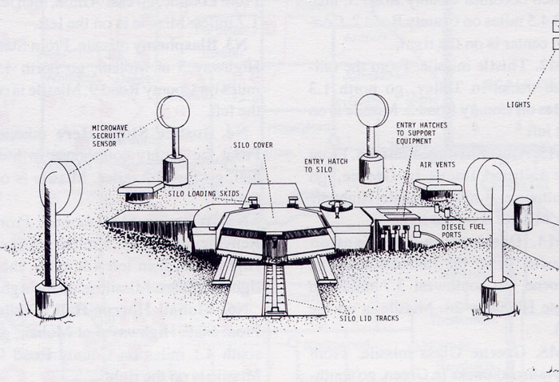

The silo lid and surrounding surface area. (drawn by Bonnie Urfer of Nukewatch) Carl hammered on the Entry Hatch padlock and combination lock inside, so no one can enter to do maintenance. Greg hammered on the silo lid, chipping away concrete, and Michael spray painted "It's a sin to build a nuclear weapon." (a quote from Fr. McSorley)
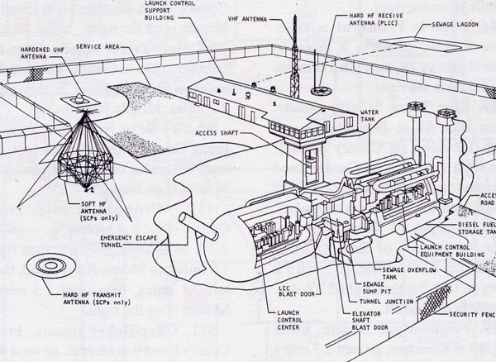

Cutaway view of a launch control center and it's underground capsule. (US Air Force)

